**1. New Features in Tableau 10 ?**

* Clustering
* Custom terrorirty
* Cross Database Join
* Design upgrade
* Device Designer
* Subscribe others

**2. The frequently used Analytics in Tableau ?**

* Forecast
* Trend line
* Clustering

**3. What are the different products that are supported by Tableau ?**

They are total 7 products which are supported by Tableau.

1. **Tableau Desktop:** It is a software which is used to generate Visualization reports.

And it is one of the Business Intelligence tool.

Tableau Desktop has two types:

* Tableau personal -- $420 , with limitations like we cannot connect to the DBs.
* Tableau Professional -- $800 , with full stake software. We can get free Tableau Professional with Student License.

1. **Tableau Public** – As name suggests it is available across the globe with certain limitations.

**Limitations:**

* Through Tableau public we can not connect to the database.
* All the work which done by Tableau public which will be saved on Tableau Server
* Through Tableau public we cannot create the extract file.

1. **Tableau Reader** – This will be used by small size company’s. We can download the report which is there in sharepoint or some where in email and open using Tableau Reader software. Generally Tableau public will useful for small size company (  Email  or Google  Drive)
2. **Tableau Online** – Tableau online will be useful by Mid size company

The cost is around $40 per user per month.

1. **Tableau Server:**

Tableau online and Tableau server will be used for sharing the reports..

we have select & edit option as well not to the extensive of Tableau professional.

we need to purchase hardware,  in order to install Tableau server. It requires additional  cost.

Maintaining the Server we need an resource which can manage server activities..

1. **Tableau Mobile:** while traveling we can analyze the data..In order  to access mobile one should have  access to Tableau Server or Tableau online.. (when users publish a report they can view it ).

**7.Tableau Prep.**

it is a Data cleaning  and data processing tool .. or ETL tool which has limited features .

One of the data Preparation and Data Transformation tool.

**4. Main Features of Tableau Prep:**

* Flow Pane: We actually build the Flows. This area also so called Canvas.
* Profile Pane : Which is used to display the distribution of data (Number of times a value has repeated) and to see distinct(Unique) values and their respective counts within their respective fields
* Another of my favorites is the ability for “fuzzy” matching on similar values, based on pronunciation or common characters. This is a game changer. Using the pronunciation-based grouping, Tableau Prep uses a phonetic algorithm to index words by their pronunciation (Context Menu option) trim out white space or specific characters from a string, group and replace similar values
* Rename
* Change the Data Type
* Change the Filed Name
* Cleaning of Null values (Include\Exclude)

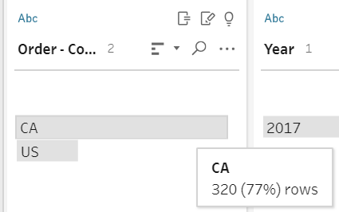

**5. What is a Data Grid ?**

Data Grid : It displays the row level representation of data. (When user click on data value in the Profile Pane , The respective data values will display in the Data Grid , It is bottom of the Page)

**6. What will happen when we add a clean step to Data Source ?**

Add a Clean step: When we add clean step , it displays the profile pane and number of records.(Shape of the table.)

We can add Filters and Calculated Fields .

**7.What is WildCard Union and Matching Pattern ?**

For this input step, we’re combining four years’ worth of orders_south.csv files using a **Wildcard** union. Using the **Matching Pattern**, we can limit the files included in this union by filename, which is very useful for filtering out a specific file out of a folder full of generated .csv or .xlsx outputs:

Example to Refer:

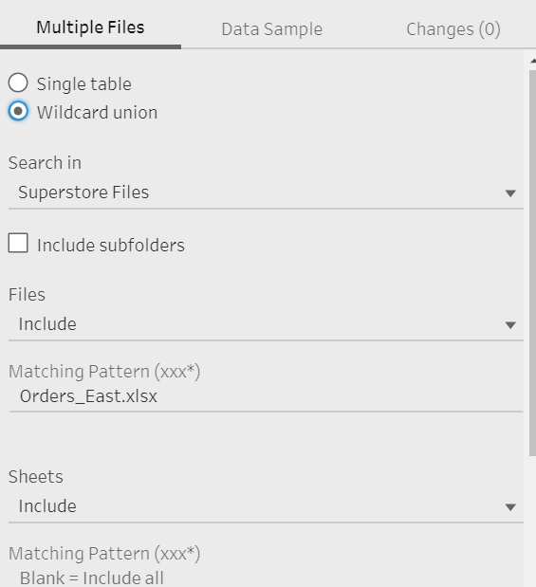

**8.What is List View in Tableau Prep ?**

**9.What are the different cleaning operations which are supported by Tableau Prep Builder ?**

Union, Pivot ,Aggregate, Join:

Aggregate : Display the data at different Granarility level.

10**. Why we do sorting in Tableau Prep ?**

Ascending and Descending

order of a column which helps how many times data value has repeated..

Q**. What do you mean by Geographic dimension?**

**11. How can we connect Tableau Prep Builder to Tableau Desktop ?**

 Right click on add step then preview on tableau desktop..

**12.What are the Major Cleaning Operations ?**

Concating

Spliting

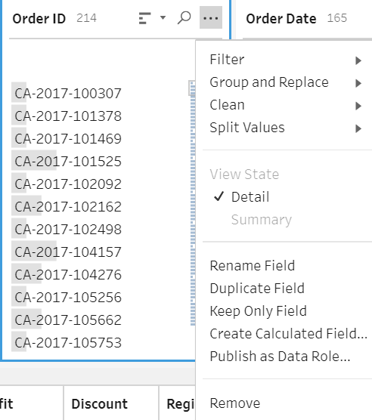

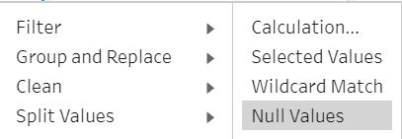

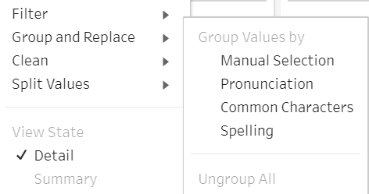

**Pronunciation** – Which automatically group the misspelled words. If the grouping is not automatically, we can do the same by editing the value.

**Common Characters**: This can be identify all the common names where first names and last name has replaced.

**Manual Selection:** This will be used to replace the values.

Replacing word by Replacing value.

Aggregation is used to change the level of detail of data

Sale – USD3.45 .., Here we need use Remove Letters option.

discounted_price = original_price - (original_price * discount / 100)

orginal_price = price , discounted_price =saleprice.

At wt step do u apply a filter – input step.

Data Intrepreter : Clening up header rows , Removing balnk columns Identify sub tables.,

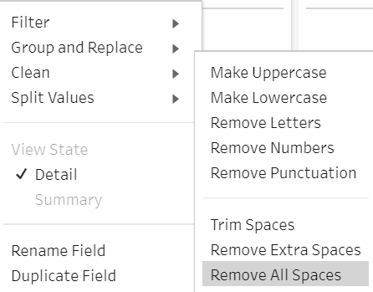

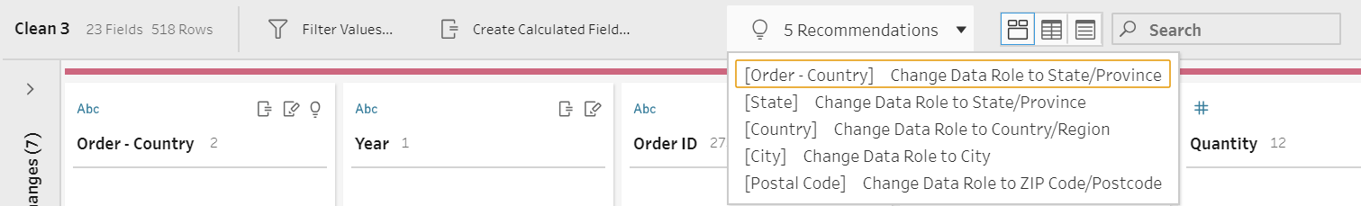

Data Grid

List View – Display the table structure and sample values.

**13.How to Generate a calculate field.**

Example profit Ratio  formula  profit by sales..

10000..10%...

**14.In How many ways can we save a report using Tableau prep Builder ?**

Tableau Data Extract .tde,

.hyper ,

.csv

**15.What are the different Joins that are supported by Tableau Prep ?**

Join..Inner join , all the records from the both table

Left join ,

all the records from the left table and common records from right table

Right join ,

all the records from right table  and common  records from left table.

Full outer join ,

all the records from left table and all the records from right table.

Cross database join  join data from two different databases..

One table from one DB  and other table from other DB

**16.Which is the preferable option for Data Cleaning ?**

We can not perform extensive cleaning in tableau desktop ..

which is slow down the performance hence we prepare to do this in Tableau Desktop.

**17. What is Pivot ?**

Pivot can be performed using Tableau Prep and Tableau Desktop..,

Pivot -- row to columns

Unpivot -- Column to Rows.

Examples ::

We can work on this..

**18.How union will work on Table Prep?**

Difference between union and Union all?

The difference between Union and Union all is that Union all will not eliminate duplicate rows, instead it just pulls all rows from all tables

fitting your query specifics and combines them into a table. A UNION statement effectively does a SELECT DISTINCT on the results set

**19. How to split the data in a given column ?**

* Custom spilt
* Automatic spilt

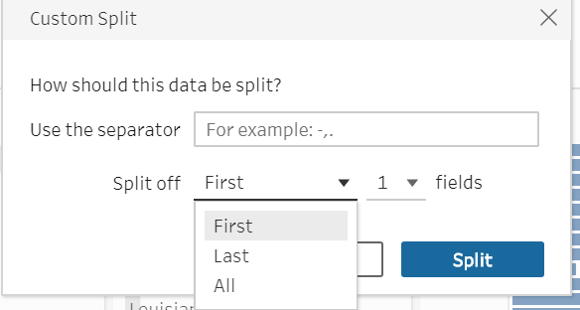

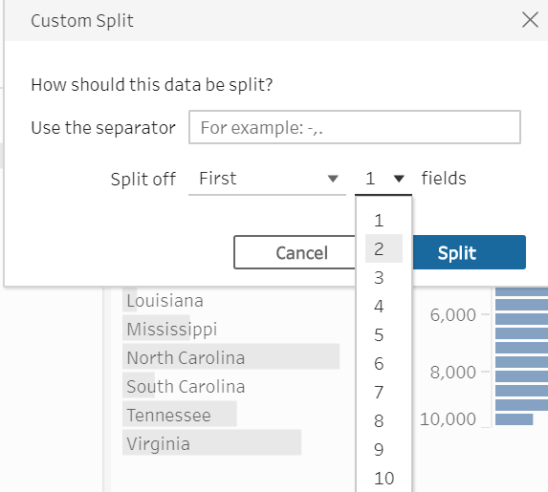

**20.How to change the column data type.**

String to whole number .. example: Year

**21. How to do Source to Target Mapping in Tableau Prep and Tableau Desktop ?**

Metadata small icon change source to target mapping User friendly  column names..

**22. How many Geographic Dimensions are available ?**

Geographic dimensions 5

state city country PC

**23. Difference between Live and Extract connections ?**

**24. What are Sales ,Profile , Profit Ratio ?**

total revenue – total expenses = **profit**. **Profit** is **calculated** by deducting direct costs, such as materials and labour and indirect costs (also known as overheads) from sales.

A sale is an exchange of money for goods, services, or other property. In accounting, net **sales** refer to the operating revenues earned by a company by selling their products or services

The **profit margin ratio formula** can be **calculated** by dividing net income by net sales. Net sales is **calculated** by subtracting any returns or refunds from gross sales. Net income equals total revenues minus total expenses and is usually the last number reported on the income statement.

**25. Display the results where Quantity less than 5 ?**

**26.How to group the exact and fuzzy matches in Tableau Prep ?**

**27. Difference between Varchar and Varchar2 ?**

Varchar converts empty string value to null , where as varchar2 inserts the data as it is.

**28. What is nvarchar2 ?**

Which handles the special characters.

**29. What are Data Sampling options in Tableau Prep ?**

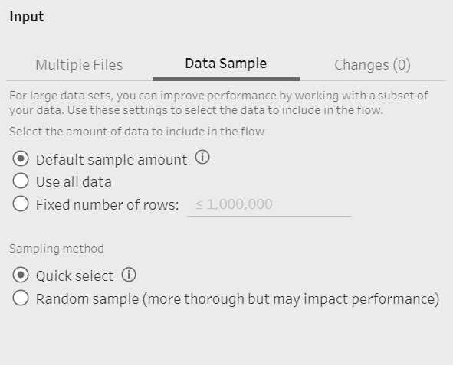

**30. First step in Table Prep ?**

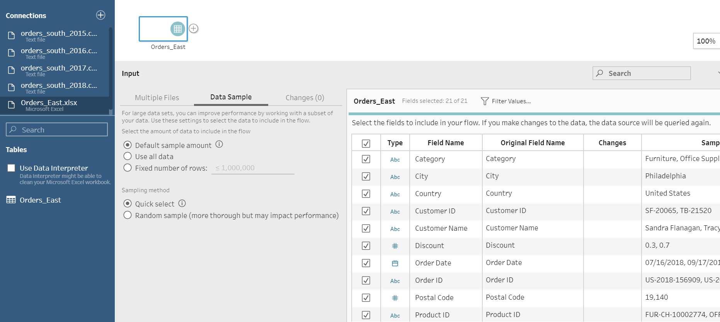

**31. How to define the Custom SQL Query in Tableau Prep ?**

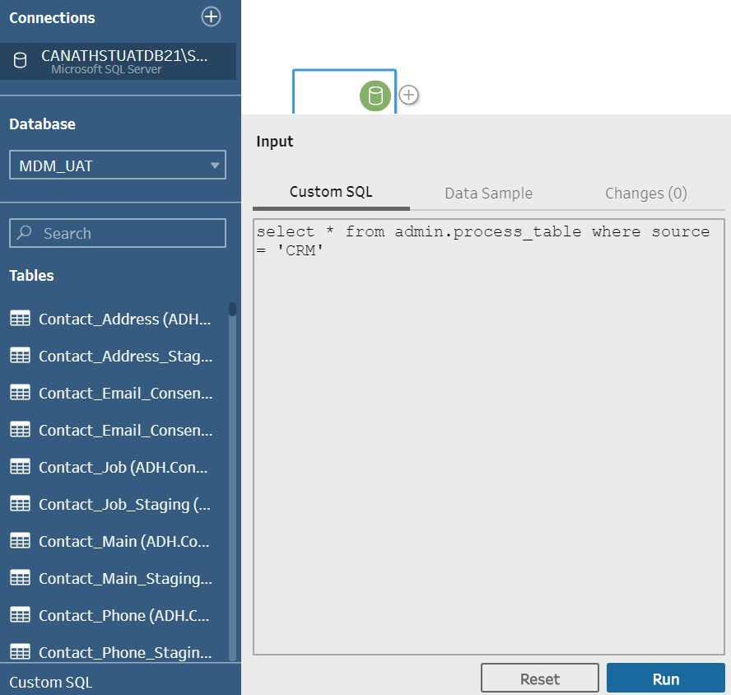

**32. LOD : Level of Detail.**

Which is used to compute the values at visualization and data source level.

* Include : More
* Exclude : Less
* Fixed : Individual level.

**33. Table Calculations:**

Which is used to compute the values at visualization level.

Types :

* Percent Form
* Difference Form
* Percent Different Form
* Table(Down)
* Table(across)
* Table(across upon down)
* Table(Down upon across)
* Pane(Down)
* Pane(across upon down)
* Pane(Down upon across)

**34. What is Data Visualization ?**

* Representation of data (from one or many sources) in a pictorial or graphical format.
* Enables decision makers to observe analytics presented visually, in order to identify and understand the trends and patterns in data.
* Data Visualization narrates a complete story that is easier to comprehend.

**35. How to achieve data visualization?**

Steps to achieve:

* Integrate
* Analyze
* Visualize

**36. Business Intelligence tool ?**

Tableau is one of the Popular business intelligence tool.

It has below features

Integrate with the R and Python Code.

Can access with Cloud Platforms

Connect with the any Kind of DS like Hadoop , MS EXCEL

100 GB cloud stortage.

**37.Why BI ?**

* Transforms the business data into Information or Knowledge
* Deliverables Relevant and reliable information, thereby enabling business users to take effective fact based decisions.

**38. Why Tableau ?**

Tableau is a powerful and fastest growing data visualization tool in used in BI industry.

**39. Main components of Tableau Server ?**

Main components -- Data Server , VizQL Server , Application Server.

**40. What is VizQl ?**

A language for query , analysis and visualization.

**41. What is Tableau prep Conductor ?**

Tableau Prep Builder: Design , run and publish data flows. Tableau Prep Conductor: Schedule and automate published data flows.

**42. What is menu Bar ?**

**43. Steps in Data Preparation ?**

* Data flow is a logical series of steps.
* Individual components of the flow are called as steps.

**44. Extension ?**

* Packaged work flow --.tflx
* Unpackaged work flow --.tfl

**45. What are the different steps in Tableau prep ?**

Input step –> Clean Step > – > Agg\Pivot\Join\Union –> Output Step.

* Input Step
* Clean Step
* Transformation Step
* Output Step

**46. Random sample** : May be better representation of Data Sample.

**47. How to filter a values based on Condition ?**

**48. Agg : Display data at a different levels of Granularity by applying operations.**

**49. Tableau UI:**

Menu bar

Sample DS : sample data source.

Tool bar

Data Pane

Shelfs – page , filter , marks (color ,size, text, detail,tooltip )

Show me – List of graphs it will display.

GC – green color , continuous value

BD – blue color , discrete value.

Canvas

Data Pane

Shelf : Columns, Rows, Page , Filter , Marks card.

Initially

it has Data Source

Sheet: Generate the reports.

Dashboard: Combination of sheets

Story:

Analytics pane : Forecast , clustering

Tableau Desktop Axes , The range of Axis is fixed. Click on the Icon to edit this.

**50. Data Types in Tableau Desktop:**

* Boolean TF
* Date
* Date Time
* Number
* Text-String
* Numerical Geographical values.

**51. What is Data Blending ? When to go for that ?**

Data is Blending is nothing but joining and aggregation.

**Reasons to use Data Blending:**

* Through cross database join when we can not join the table.
* When data is at different granularity level. (Data is at different levels of data)
* Dealing with Huge amount of data
* Data needs some cleaning.

**52. What are the Primary and Secondary Data Source ?**

**Primary Data Source** : It indicates

**Secondary Data Source**: It indicates in Orange color.

**53. What is the Automatic data blending ?**

It happens when we do data blending , we can not always rely on this blending , sometimes we need to add additional columns as well.

Data Blending is to issue two separate queries and then to blend them together to get aggregate results.

**54. Any data in the source which will get automatically reflected here**

i.e Live Connection.

**55. What are the connection types in Tableau ?**

Live and Extract.

**56. What are the Features of Tableau Desktop ?**

Great Visualization

Faster Insights

Connect to more Data

Answer deeper Questions

Put your data on Map

Share and Collaborate

**57. When to use Live\Extract Connection ?**

Both types of connections have their usage based on the requirement.

Live Connection to make real time decisions by monitoring the incoming patient records. Extract of data source helps to build visualization to monitor daily and weekly trends.

**58. Difference between Join and Blending.**

**Join :**

* Which is at row level.
* Single Query to a single DS.

**Blending:**

* Which is at aggregate level.
* Different Queries sent to each DS.

**59. Why Tableau Prep.**

* Prepares data at a faster pace for analysis.
* Help transform and shape data.
* Visually combines , instantly reshapes and quickly cleans the data from multiple sources.
* Get faster insights into the data and make better business decisions.

**1.Tableau Prep** : Data Preparation tool that helps combine , shape and clean the data for analysis.

**2.Tableau Desktop** : Authoring and publishing tool that is used to create shared views on Tableau server.

**3.Tableau Server:** Business Analytics platform wherein we publish, store and schedule automatic refreshes on the web.

**4.Tableau Online**: Analytics platform fully hosted in cloud version of Saas.

**5.Table Mobile:** It is a free app available on both Android and IOS Env. You can use it explore and share views published to Tableau server or Table online.

**6.Tableau Public**: It is free product from Tableau , allowing Visualization enthusiast to play with data with some restrictions.

**7.Tableau Reader:** Free application that lets anyone view and interact with Tableau packaged workbooks.

**60. Types of Graph ?**

**Line graph.** Line graphs are used to track changes over short and long periods of time. When smaller changes exist, line graphs are better to use than bar graphs. Line graphs can also be used to compare changes over the same period of time for more than one group.

**Pie Chart.** Pie charts are best to use when you are trying to compare parts of a whole. They do not show changes over time.

A Pie Chart is best suited to show proportional or percentage relationships

**Bar Graph.** Bar graphs are used to compare things between different groups or to track changes over time. However, when trying to measure change over time, bar graphs are best when the changes are larger.

**Stacked Bar Graph: Adding another level of detail in the Bar Chart.**

**Simple Bar Graph**

Bar Graph : Visually represents data in a way that makes comparison of values simpler.

**61. What is Area Graph ?**

**an Area Graph.**Area graphs are very similar to line graphs. They can be used to track changes over time for one or more groups. Area graphs are good to use when you are tracking the changes in two or more related groups that make up one whole category (for example public and private groups).

Area Chart is a Line chart wherein the area between the line and the axis are shaded.

**61. What is Scatter Plot?**

Scatter Plot: When two or more measures are required then we need scatter plot.

**62.What is Historgam ?**

Historgram : Continuous distribution.

**63. Why do we require Visual Analytics ?**

Interactive graphical display of data to genearte analytical results and insights.

Improves Decision Making , Better sense of Risk , Better key Strategic Initiative , Good Financial Performance.

**64. What is Trend Line ?**

 A **trend line** is a straight **line** that connects two or more price points and then extends into the future to act as a **line** of support or resistance

**65. What is Data Granularity ?**

Data Granularity : Granularity is the level of depth represented by the data , in a fact or dimension table.

High Granularity: Detailed view of data and transactions.

Low Granularity: Zooms out into a summary view of data and transactions.

**66. Features of Tableau Desktop:**

Highlighting

Sorting

Filtering : How to make sheet as Target mapping ?

Grouping

Set:

Parameters:

Tooltip:

**67. Why Caluatiosn ?**

Extends the possibilities for analysis and design , Provides additional flexibility in interactivity , Adds creative functionaility to visualization.

**68. Math Cal ?**

Ceiling , Power , Round.

Right (Product_id,4) – last 4 didghts

Dateadd , Datename , day , now , if null ,isdate,min,min,attr

**69.**

**Table cal**: Partitioning (Data is partitioned , and table caluation is performed within each partition) , Addressing (Determines the direction in which the calculation moves)

Quick Table Claution : Class 4

Lod CALAUATION :

Include, exclude,fixed

70.

Trenlines

Reference lines

Forecasting

Clustering

71. What does the average tell you about the data?

Averages are useful because they: summarise a large amount of **data** into a single value; and. indicate that there is some variability around this single value within the original **data**.

Variability : lack of consistency or fixed pattern; liability to vary or change.

trend : a general direction in which something is developing or changing.

72.You can add a reference line, band, distribution, or box plot to identify a specific value, region, or range on a continuous axis in a Tableau view. For example, if you are analyzing the monthly sales for several products, you can include a reference line at the average sales mark so you can see how each product performed against the average.

73.

Maps:

Geographical dimensions. (State, City, Country , Postal Code)

Change the back ground of Map.

Custom terririty – creating groups.

74. sets can be combined if we create both on same dimension.

<https://www.tableau.com/support/releases?_ga=2.215462751.999435083.1579525810-2120864333.1579115486>

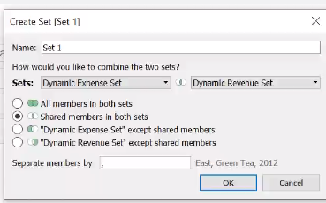

77.

Add reference line, If percentages of time spent in the **target quadrant are** significantly higher than

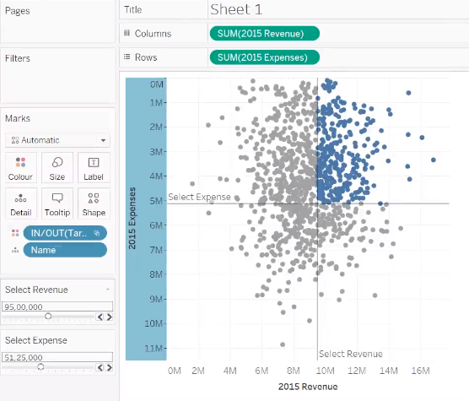

Setting colors for multiple sets.

Applying colors for multiple sets as well.

How to apply colors for multiple sets together atonce.

Sets are nothing conditional type of group

Dynamic set by using parameters

Conidition , top, filter

Adding a reference line.. Make reference line dynamic.

Text Tables:

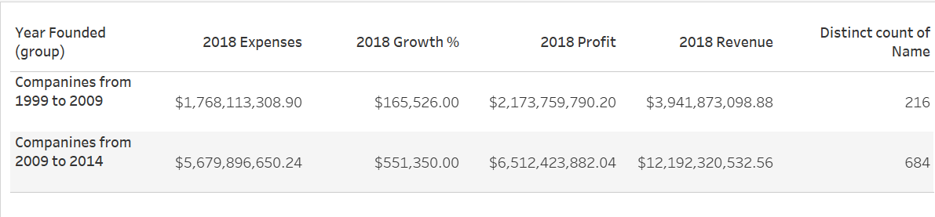

Horizontal Bars

Stacked Bars

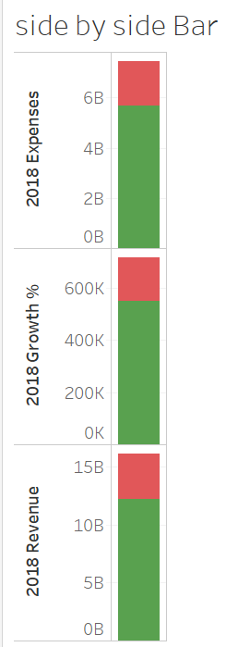

Side by Side Bars:

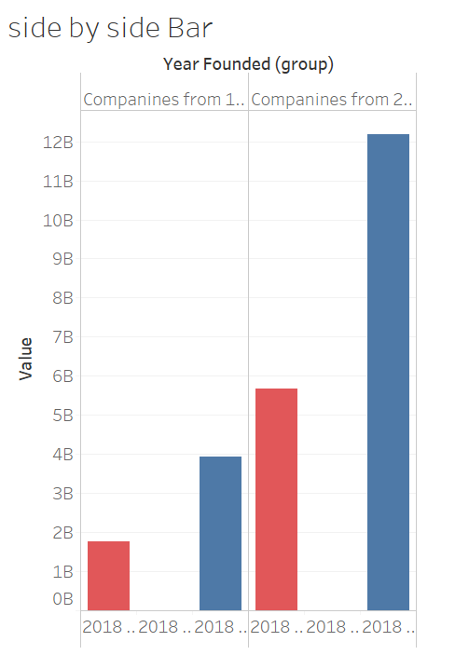

Box and whisker plots:

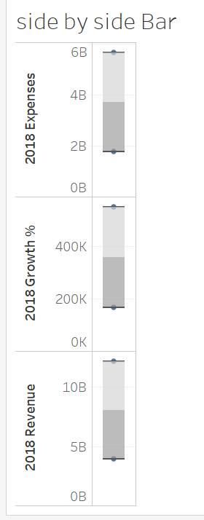

Gnatt Charts:

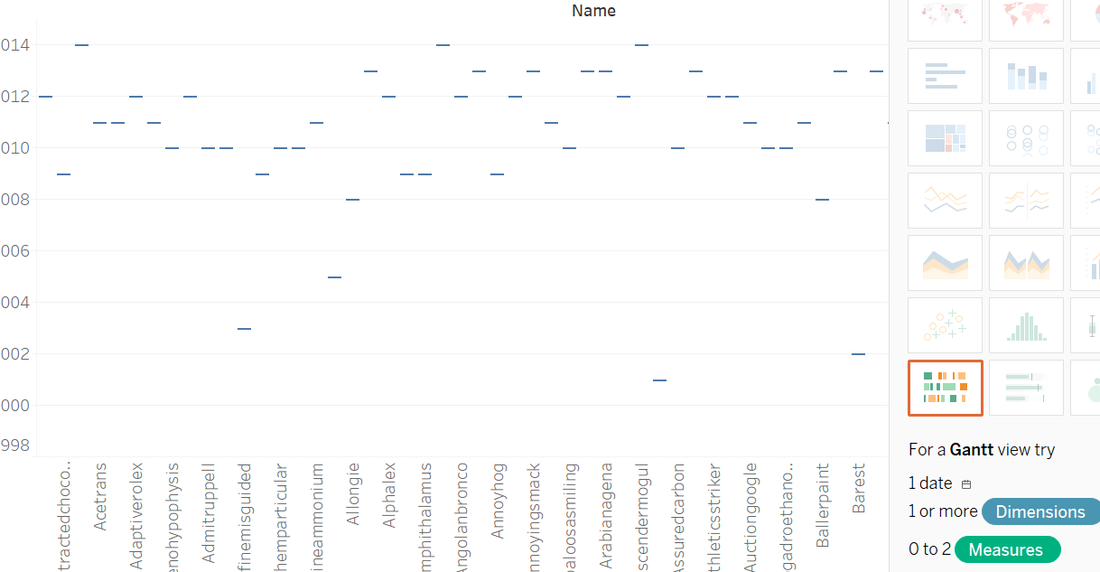

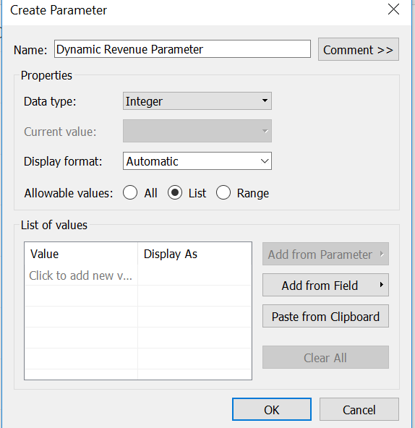

Automatic

Standard Number

Standard Custom

Currency Standard

Currency format

Percentage

Scientific.

(sum([2018 Revenue]) > 10000000

and sum([2018 Revenue]) < 18000000)

and

(sum([2018 Expenses]) > 10000000

and sum([2018 Expenses]) < 18000000)

In linear correlation the coefficient quantifies the strength and direction of the correlation between the variables.

1/(SIZE()-1) * WINDOW_SUM(( (SUM([Profit])-WINDOW_AVG(SUM([Profit]))) /

WINDOW_STDEV(SUM([Profit]))) * (SUM([Sales])-WINDOW_AVG(SUM([Sales]))) / WINDOW_STDEV(SUM([Sales])))

**Programs:**

<https://www.thedataschool.co.uk/emily-dowling/calculate-correlation-coefficient-tableau/>